IDB LAB-4

1. Create table Student(student_id varchar(20), student_name varchar(30),  
marks number,grade varchar(2));

2. insert into Student(student_id,student_name,marks,grade)values(‘GA-001’, ’Jhon’, 285,’A’);

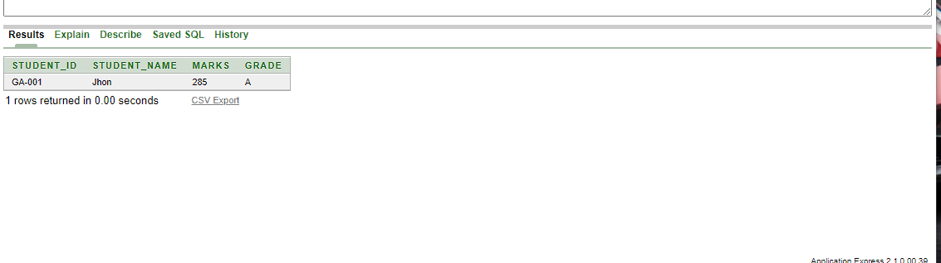

3. insert into Student values('GA-002', 'Smith', 248,'B');

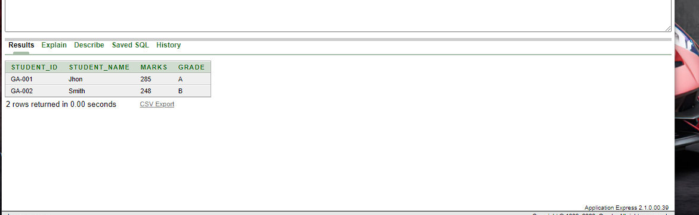

4. insert into Student values('GA-003', 'Emma', 329, 'A+');

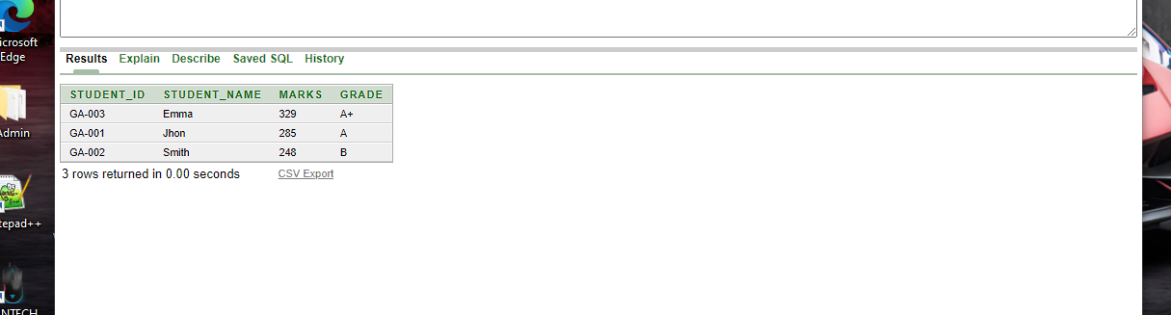

5. insert into Student values('GA-004', 'Sandy', 249, 'B');

6. insert into Student values('GA-005', 'Olivea', 150, 'F');

7. insert into Student values('GA-006', 'James', 187, 'D');

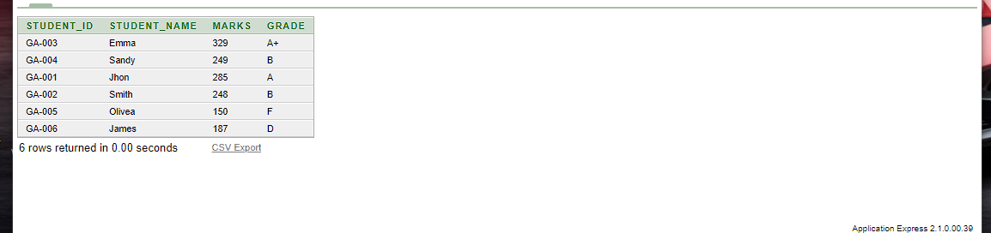

8. insert into Student values('GA-007', 'Eva', 352, 'A+');

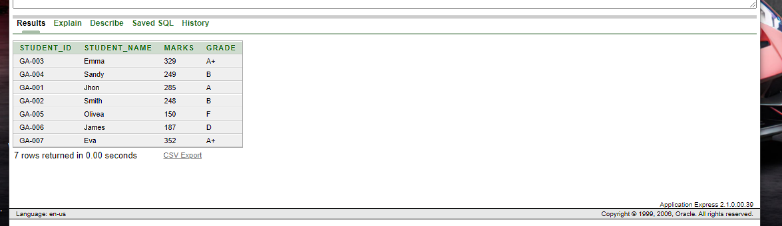

9. insert into Student values('GA-008', 'Noah', 279, 'B');

10. insert into Student values('GA-009', 'Charlotte', 282, 'A');

11. insert into Student values('GA-010', 'Elijah', 301, 'A');

Student Table:

